Class 7

**Lecture 11**

**Web**

**Search Engine, Web Browser, Protocol**

**Internet**

**&**

**Web**



**Lab Objectives:**

* Mechanism of Web Browser
* Web Protocol Overview
* Search Engine with example.

**What is Web Browser?**

A web browser (commonly referred to as a browser) is a software application for accessing information on the World Wide Web. Each individual web page, image, and video is identified by a distinct URL, enabling browsers to retrieve and display them on the user's device.

Browsers translate web pages and websites delivered using Hypertext Transfer Protocol (HTTP) into human-readable content. They also have the ability to display other protocols and prefixes, such as secure HTTP (HTTPS), File Transfer Protocol (FTP), email handling (mailto:), and files (file:). In addition, most browsers also support external plug-ins required to display active content, such as in-page video, audio and game content.

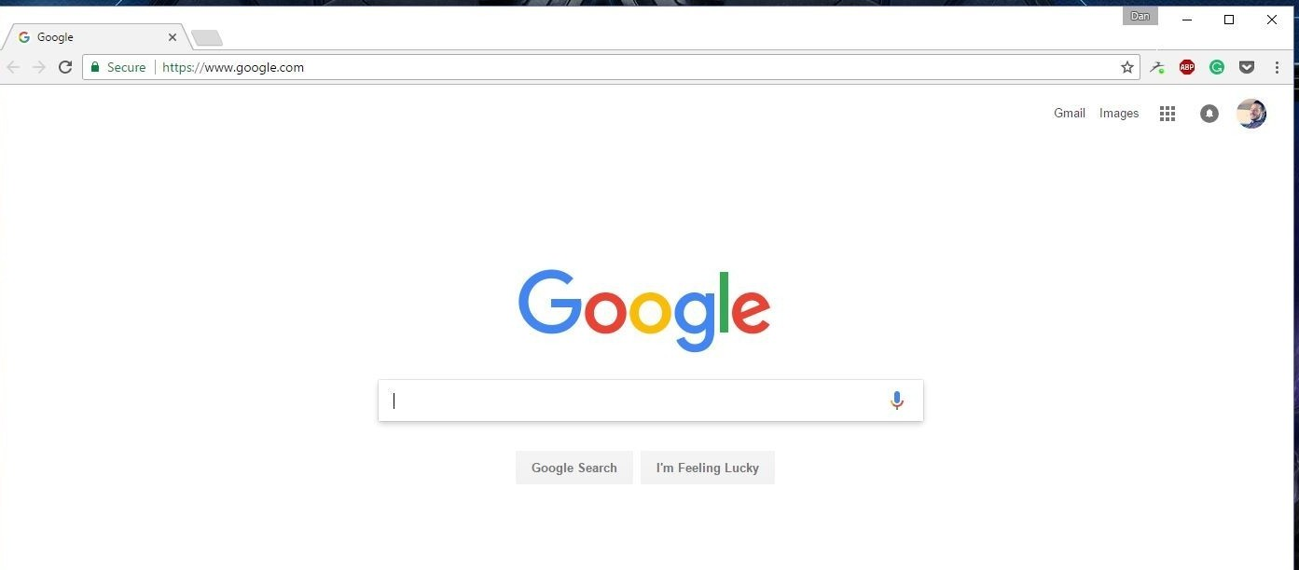

A variety of web browsers are available with different features, and are designed to run on different operating systems. Common browsers include Internet Explorer from Microsoft, Firefox from Mozilla, Google Chrome, Safari from Apple, and Opera. All major browsers have mobile versions that are lightweight versions for accessing the web on mobile devices.

The first web browser, called WorldWideWeb, was invented in 1990 by Sir Tim Berners-Lee.He then recruited Nicola Pellow to write the Line Mode Browser, which displayed web pages on dumb terminals; it was released in 1991.

**Browsers' benefits and key features**

* They're free to download.
* You can have more than one on your computer.
* They all work in a similar way.
* They allow users to explore websites anywhere on the internet.
* Can be personalised by allowing users to add favourites or set a different home page (the first page that you see when you open your browser).

. Here are the most popular browsers and their user number in percentage:

* Google Chrome
* Apple Safari
* UC Browser
* Mozilla Firefox
* Internet Explorer

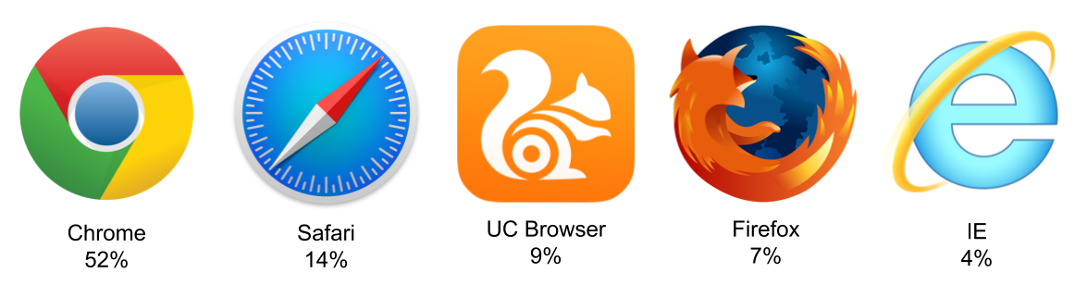

**Example: Google chrome browser interface analysis**

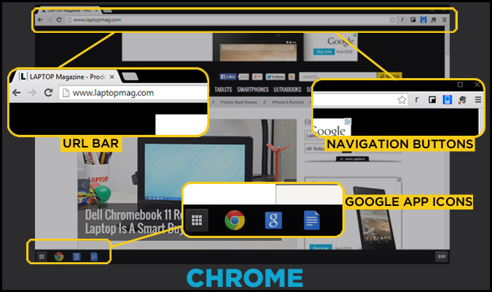

**URL**

URL stands for Uniform Resource Locator, and is used to specify addresses on the World Wide Web. A URL is the fundamental network identification for any resource connected to the web.

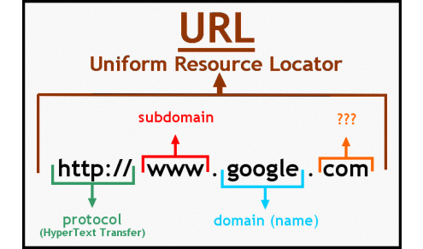

**Web Protocol**

The Internet relies on a number of protocols in order to function properly. A protocol is simply a standard for enabling the connection, communication, and data transfer between two places on a network. Here are some of the key protocols that are used for transferring data across the Internet.

1. **HTTP**

HTTP stands for Hypertext Transfer Protocol. It is the standard protocol for transferring web pages (and their content) across the Internet. When you browse a web page, the URL might be preceded by ***http://.*** This is telling the web browser to use HTTP to transfer the data. Most browsers will default to HTTP if you don't specify it. You can test this by typing in say... ***www.quackit.com*** (instead of ***http://www.quackit.com***).



1. **HTTPS**

HTTPS stands for Hypertext Transfer Protocol over Secure Socket Layer. Think of it as a secure version of HTTP. HTTPS is used primarily on web pages that ask you to provide personal or sensitive information (such as a password or your credit card details).

There was a time when HTTPS was typically only used on sites (or sections of sites) where sensitive data was being provided by the user. But more recently, it has become the norm, even on information based websites where no such data is transferred.

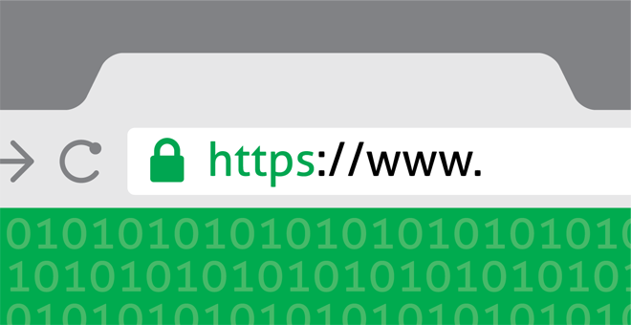

1. **FTP**

FTP stands for File Transfer Protocol. It is used to transfer files across the Internet. FTP is commonly used by web developers to publish updates to a website (i.e. to upload a new version of the website).

**Search Engine**

Search engine is a service that allows Internet users to search for content via the World Wide Web (WWW). A user enters keywords or key phrases into a search engine and receives a list of Web content results in the form of websites, images, videos or other online data. The list of content returned via a search engine to a user is known as a search engine results page. The information may be a mix of web pages, images, and other types of files.

Some Popular Search Engine:

* Google. (www.google.com)
* Bing. (www.bing.com)
* Duck Duck Go.

(www. DuckDuckGo.com)

* Yahoo (www.Yahoo.com)

